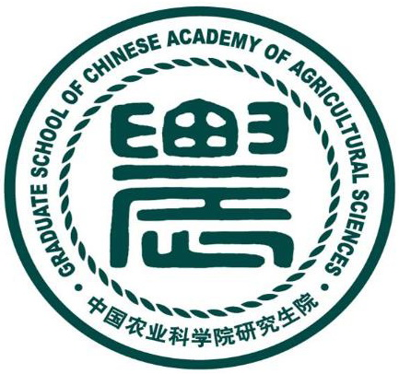
International Training Workshop
on High Efficient Plant Factory Technology
October 12-31, 2015
Beijing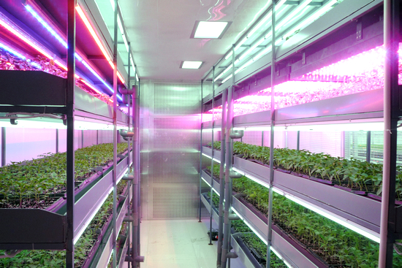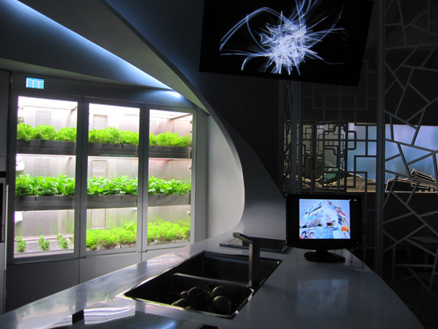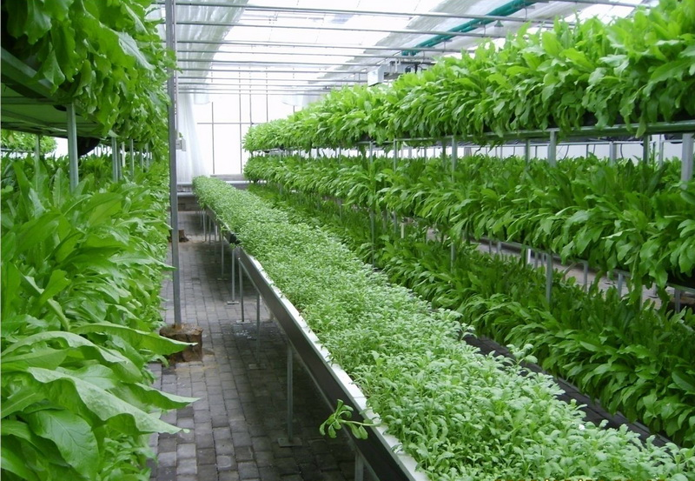
Ministry of Science and Technology, P. R. China
Graduate School of Chinese Academy of Agricultural Sciences
(GS，CAAS)
Institute of Environment and Sustainable Development in
Agriculture of CAAS
（IESDA，CAAS）

Program Announcement

International Training Workshop on High Efficient Plant Factory Technology
October 12-31, 2015
Beijing

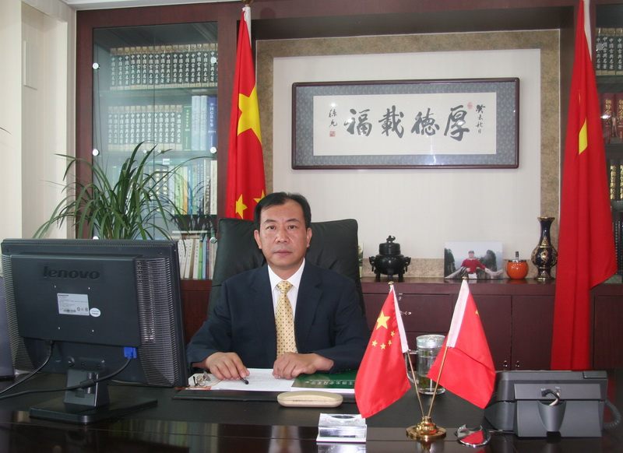
Vice President of GSCAAS ， Professor Han Huipeng

Purpose of the Training Workshop
The training workshop aims to introduce research achievements and applications of the plant factory technology in China, promote the development and application of high-efficiency in production with science and technology on vegetables, flowers and other horticultural products for developing countries, and enhance staff ability of management. The workshop also intends to speed up the transfer of Chinese high-tech agricultural technologies and strengthen cooperation and exchanges between China and other developing countries.
The Overview of the Training Workshop
- Brief description
The first plant factory in China was developed by Chinese Academy of Agricultural Sciences (CAAS) which has many years of experience on research and production. The plant factory applied by CAAS aids the steady production of high-quality vegetables all year round by artificial controlling the cultivation environment (e.g., light, temperature, humidity, carbon dioxide concentration, and culture solution). By controlling the internal environment and using multi-shelf system, plant factories can produce about 2-4times more vegetables than was possible in the typical outdoor cultivation.
- Main contents
- Plant factory conception, types, development status and trends
- Plant factory environment control technology, including energy saving light environment control ( LED light source application ) technology, temperature control technology, the humidity control technology, CO₂ control technology
- Plant factory efficient production techniques, including multilayer cultivation technology, nutrient recycling technology, hydroponics and aeroponics efficient cultivation technology
- Practice ability training of plant factory
- Field visit of facility agriculture
Eligibility
At most 20 members are allowed in the workshop. Preference will be given to qualified candidates from developing countries. Each country may nominate a maximum of 4 candidates. Participants should at least have a bachelor’s degree and a minimum of 3 years working experience in the field of facility agriculture engineering. Applicants must master speaking and writing skills in English. For those countries, in which English is not an official or customary language, a copy of certificate of English proficiency should be provided. The certificate must be issued by language schools, cultural institutes or the embassy of the country. The applicants must prove well-being of health by submitting a health certificate. The age limit is under 45 years old. When an applicant registers, he/she should submit a research report in the field of facility agriculture engineering (If more than one candidate come from the same country, only one report will be required).The applicants who are working and studying in China presently could not enroll.
Application Procedure
- Login into our website as follows to register (https://168.160.11.33/student_login.aspx)
- A complete Application Form must be submitted to the designated email address in scanned copies before July 15, 2015. Contact our workshop officer for the Application Form by email.
Administration and Financial Arrangements
A round-trip airfare from home country to Beijing will be afforded by participants or their nominating organizations.
Chinese Government will pay the costs of hotel accommodation (2 participants will share a room), meals and local transportation for participants during the training period. All local arrangements for travels in Beijing, food, accommodation, and sightseeing tours will be covered by the host organization.
Participants should cover their own expenditure unrelated to the training workshop in China. The organizer of this workshop do not admit liability for the payment of any cost or compensation that caused by damage or loss of personal property, nor accident from illness, injury, disability, or death of a participant while he/she is on the way to and attending the workshop. It is clearly understood that each government or agency, in nominating participants, undertakes responsibilities for such coverage. Therefore governments or institutions of nominating concerned would be strongly advised to take out insurance against these risks.
The Ministry of Science and Technology of China and GSCAAS request that the government countries acknowledge the aforementioned workshop and recommend their candidates.

Sponsor: Department of International Cooperation, Ministry of Science and Technology,
P. R. China; 15B Fuxing Road, Beijing 100862, P. R. China
Organizers: Graduate School of Chinese Academy of Agricultural Sciences (GSCAAS)
The Institute of Environment and Sustainable Development in Agriculture (IESDA)
Zhongguancun Nandajie, Haidian District, Beijing 100081, P. R. China
Training workshop Dates: October 12-31, 2015
Application Deadline: July 15, 2015
Language: English.

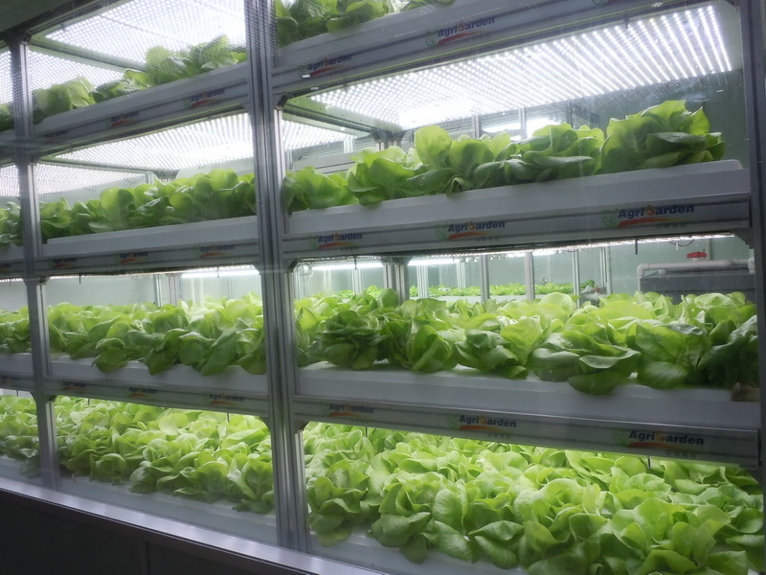
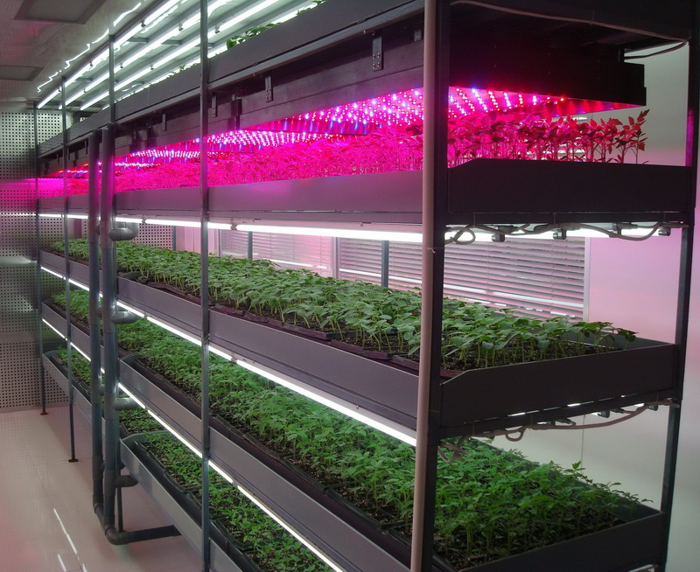

About the Host Organizations
The Graduate School of Chinese Academy of Agricultural Sciences(GSCAAS), founded in 1979, is one of the first batch of universities and institutes to grant the doctorate and master degree in China. Backed up by 39 research institutes all over 17 provinces, municipalities and autonomous regions in China, GSCAAS has various student body, including Ph.D candidates, post Ph.D candidates, on-job postgraduates, professional degree students, and international students. The number of registered students has exceeded 4300, and 2700 of whom are full-time students.
Presently GSCAAS has 1144 supervisors, including 418 supervisors for Doctoral Programs, 2 academicians of Chinese Academy of Science and 9 academicians of Chinese Academy of Engineering. There are 4 main subject categories, including Natural Sciences, Engineering Sciences, Agriculture and Management Sciences. With the joint effort of the institutes of CAAS, GSCAAS excels in teaching and training.
GSCAAS cooperates with agricultural institutes and universities from more than 60 countries worldwide. The cooperation has diverse forms, such as the student exchange programs and joint programs for graduate students. The long-term bilateral relationships with Ohio State University in USA and with the Wageningen University in Netherlands are the highlights. Since 2008, GSCAAS had launched international student education program. So far, more than 130 students enrolled are from countries in Asia, Africa, Europe and North America.
The Institute of Environment and Sustainable Development in Agriculture (IESDA) of CAAS, as a cooperative organization of the training workshop, is the earliest institute engaging in plant factory technology research. It has made important progress in plant factory technology of high-efficiency resource utilization. In recent years, the application of the technique has strongly supported the horticultural production.

Workshop Contact Officer:
Ms. Huizhen Peng
Graduate School of Chinese Academy of Agricultural Sciences
Mail: 12 Zhongguancun Nandajie, Beijing 100081, P.R. China
Tel: 0086-10-82109750
Fax: 0086-10-82109750
Email: penghuizhen@caas.cn

