The 4th Training Course of Chinese Senior Aquafeed Formulator

The 4th Training Course of Chinese Senior Aquafeed Formulator will be held in Beijing from March 1st to 2nd, 2014 and be focused on the theme of "the nutritional synergistic and antagonistic effects in aqua animals". Thus far all the invited speakers have been confirmed and among them are Academician Kangshen Mai from Ocean University of China, professor Xiaoqiu Zhou from Sichuan Agricultural University, professor Yuantu Ye from Soochow University, Cargill Aquaculture Technology Leader Dr. Andy Pei, Tongwei Fisheries Research Institute Director Dr. Haifeng Mi, Guangdong Yuehai Group Technology Director Dr. Kaimin Cheng and other experts. Up to 600 participants is expected to attend this conference.
Since 2003 when the first course was founded, the number of participants has been consecutively increased in the past three sessions with ~100 for the first, ~200 for the second and ~300 for the third one, which was as a result of specific course theme covering industry hot topics, enormous influence of the invited speakers and other wonderful features in each session.
The success of the conference relies on the trust and support of the peers like you. We are grateful and kindly invite you to participate the 4th training course of Chinese Aqua Feed Senior Formulator. See you in Beijing!

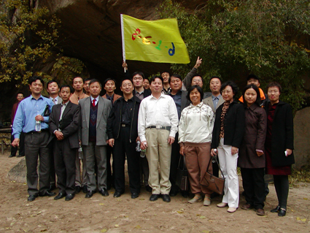 | 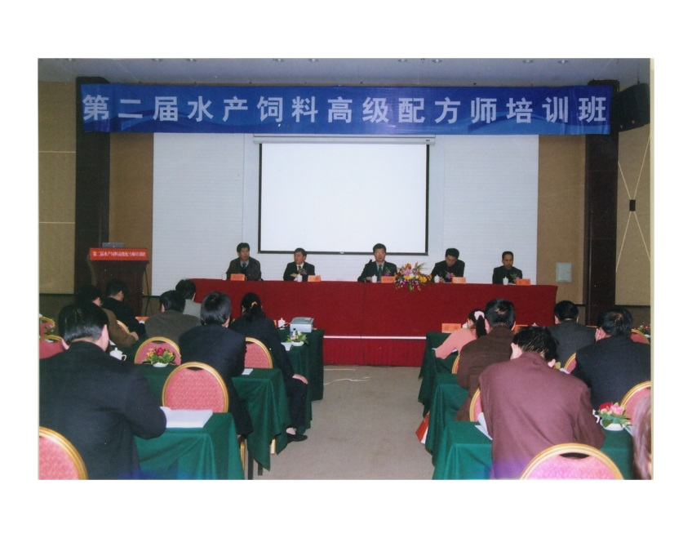 | 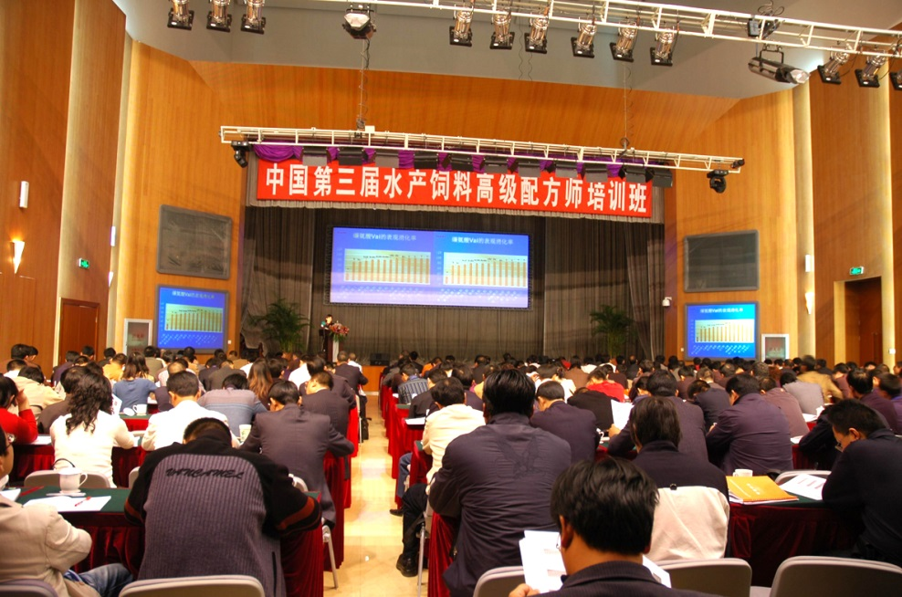

Organizer：
Feed Research Institute of Chinese Academy of Agricultural Sciences;
National Society of Animal Nutrition of Chinese Association of Animal Husbandry and Veterinary Medicine

Undertaker：
The Aqua Feed Innovative Team of Chinese Academy of Agricultural Sciences;
Beijing Enhalor Biotechnology Co., Ltd

Co-organizer and sponser:
Guangdong VTR Bio-Tech Co., Ltd
Tongwei Group
Hubei Oteo Bio-Tech Co., Ltd
Guangdong Atech Bio-Tech Co., Ltd
To be recruited

The theme of this course: the nutritional synergistic and antagonistic effects in aqua animals
Time: March 1 – March 2, 2014
Place: Beijing

Executive secretary: Prof. Zhigang Zhou, Prof. Min Xue, and Dr. Zelin Ren

Registration fee: 300 USD/person pre February 22, 2014, and 500 UDS/person in site.
Contactor：Ms. Zhang, +8615210464360；+861082106089；mei_chao_zhang@163.com
Mr. Lorry, +8618911641790; +861062142592-869; mjzhao2008@sina.com

Beneficiary Bank: Agricultural Bank of China Beijing Branch
SWIFT Code: ABOCCNBJ
Beneficiary A/C No: 11050601040009775
Beneficiary Name/Address:
Feed Research Institute, Chinese Academy of Agricultural Sciences,
No 12 Zhongguancun Nandajie, Haidian
Beijing 100081, China
Tel/fax: 8610-82106056/82106054

Schedules |  | Topics | Tutor | Work Unit
March 1, 2014
 | 8:00-8:05 | Remark by Academician Kangsen Mai
 | 8:05-8:10 | Remark by Head of Feed Research Institute
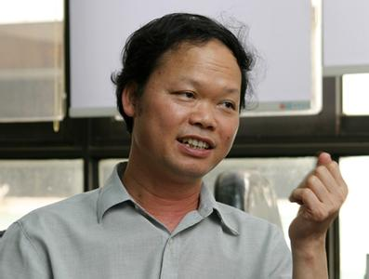 | 8:10-9:00 | The bottleneck of protein resources in Chinese feed industry | Academician Kangsen Mai | Ocean University of China
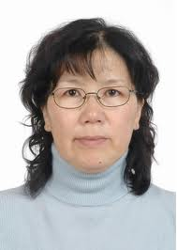 | 9:00-9:40 | Encoding and replacing the unknown nutritional factors in fishmeal and animal protein meal | Prof. Mengqing Liang | Yellow Sea Fishery Institute of Chinese Academy of Fishery Science
 | 9:40-10:10 | Group photo
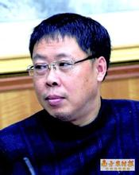 | 10:10-10:50 | Evaluation of new feedstuffs in the Feedstuff Directory | Prof. Yuantu Ye | Soochow University
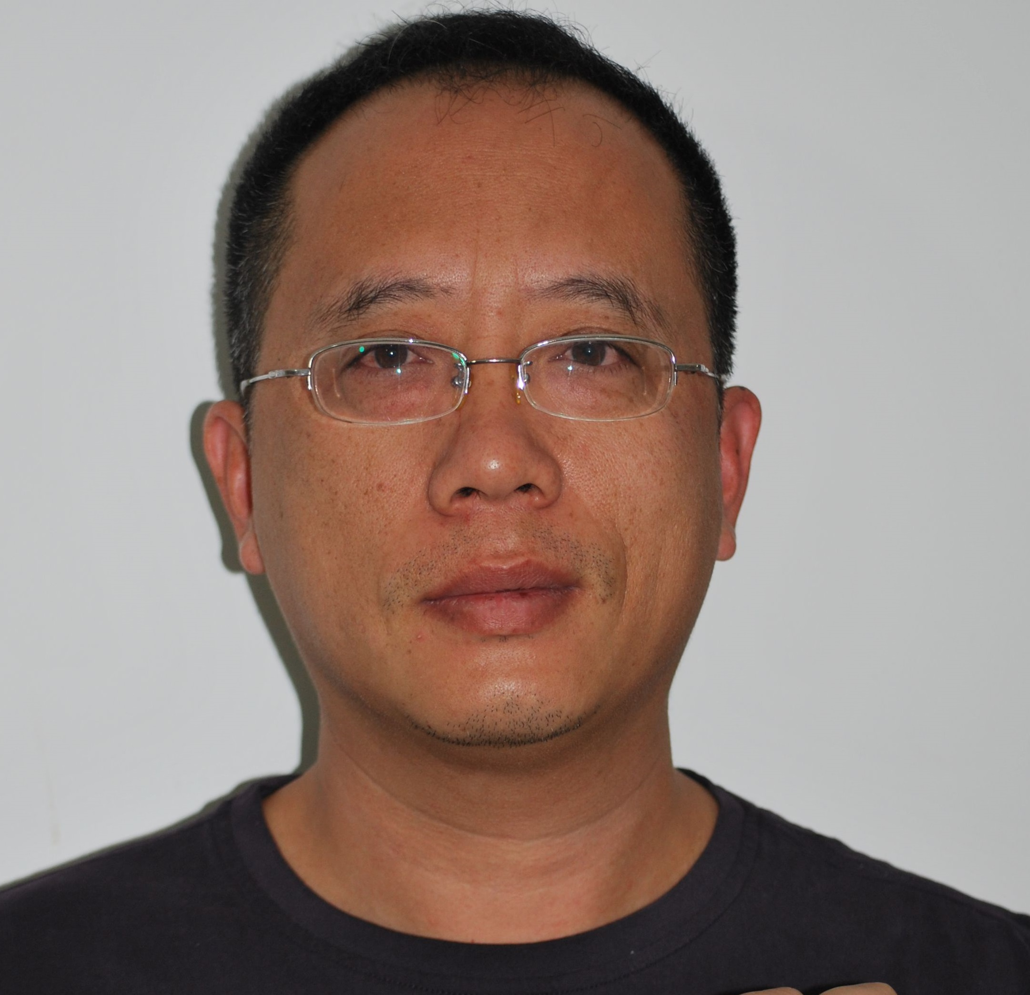 | 10:50-11:30 | Promotion of nutritional value of feedstuff by microbial fermentation | Senior Engineer Hongxing Xiang | Chengdu Biology Institute of Chinese Academy of Sciences
 | 11:30-12:00 |  |  | Co-organizer 1
 | 12:00-12:30 | Question and discussion
March 1, 2014
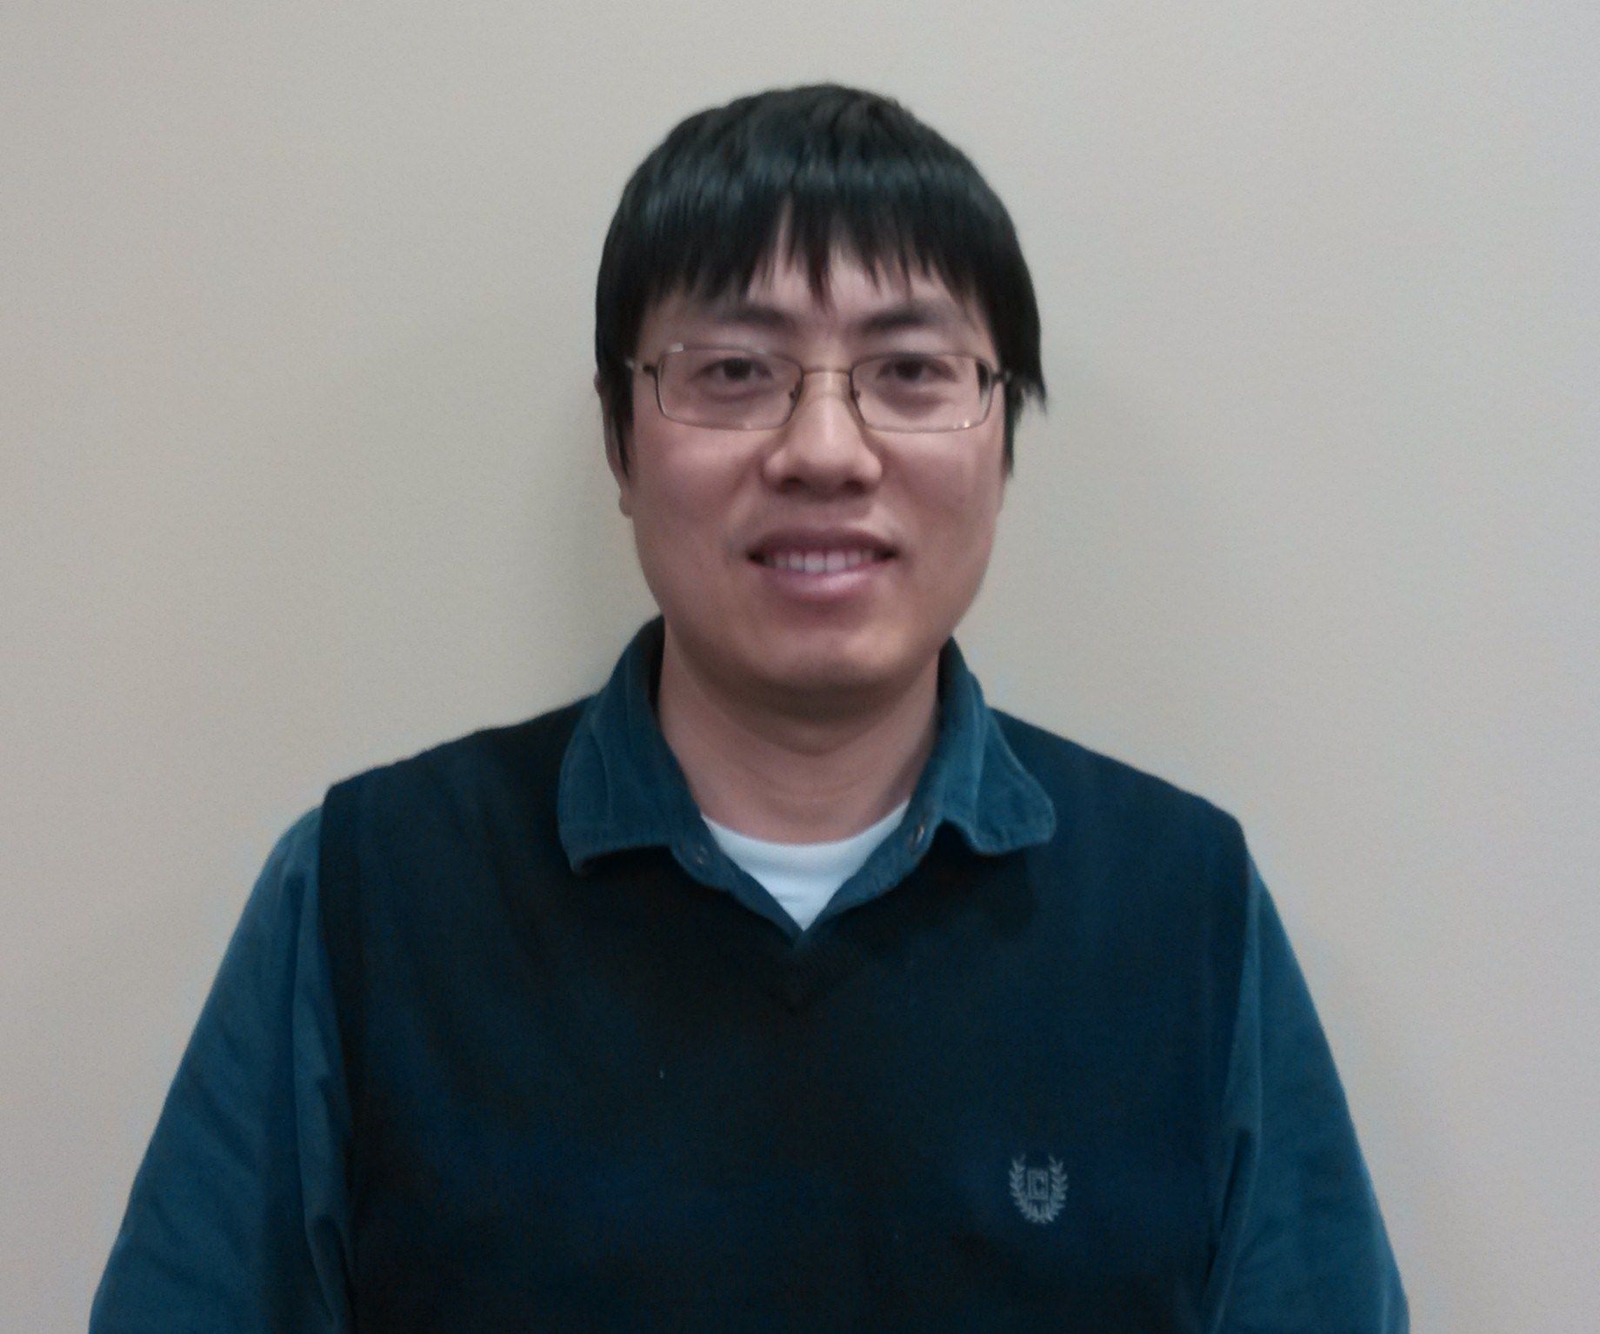 | 14:00-14:40 | Synergism and antagonism of nutrients in aquaculture animal | Dr. Andy Pei | CARGILL, Incorporated
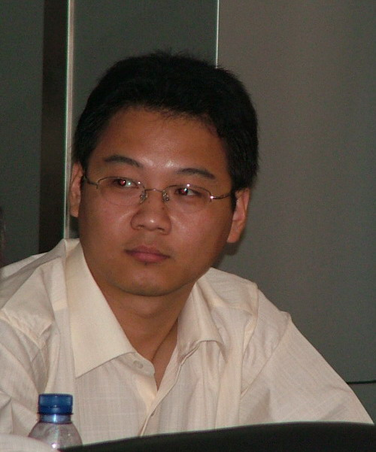 | 14:40-15:20 | The debate over nutrition standards in aqua feed | Dr. Dong Han | Institute of Hydrobiology, Chinese Academy of Sciences
 | 15:20-15:30 | Coffee break
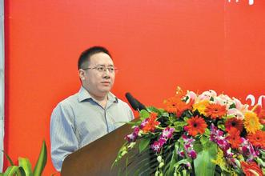 | 15:30-16:10 | Precise match between stocking density and aquafeed quality | Prof. Xiaoqiu Zhou | Sichuan Agricultural University
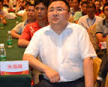 | 16:10-16:50 | The principle and adjustment of aqua feed formulation under water temperature stress | Dr. Haifeng Mi | Tongwei Fishery Institute
 | 16:50-17:10 |  |  | Co-organizer 2
 | 17:10-17:30 |  |  | Co-organizer 3
 | 17:30-18:00 | Question and discussion
March 2, 2014
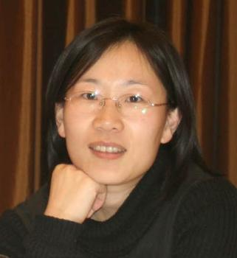 | 8:00-8:40 | Feed Formulation sturgeon and trout | Prof. Min Xue | Feed Research Institute of Chinese Academy of Agricultural Sciences
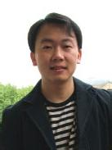 | 8:40-9:20 | Feed Formulation tilapia and triploid crucian carp | Dr. Song Zhang | Guangzhou Hinter Biotechnology Co., Ltd
 | 9:20-9:50 |  |  | Co-organizer 4
 | 9:50-10:00 | Coffee break
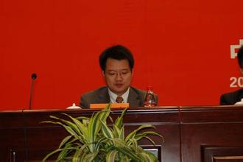 | 10:00-10:40 | Feed Formulation catfish and black carp | Superintendent Wenhao Zhou | Beijing Enhalor International Tech Co., Ltd
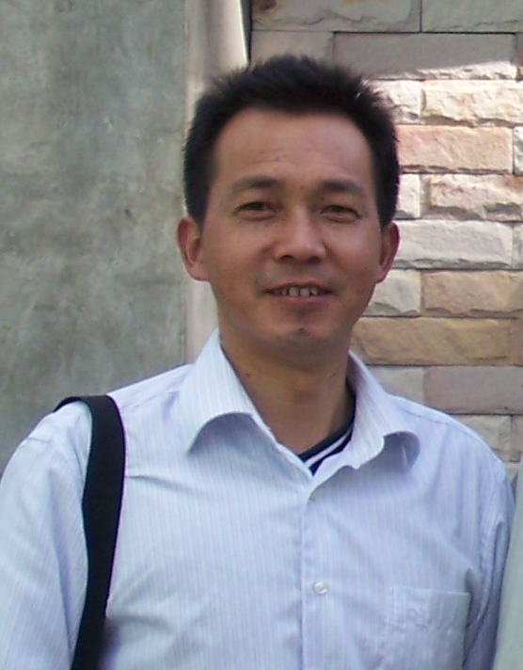 | 10:40-11:20 | Feed Formulation Loach, ricefield eel, and yellow-head catfish | Superintendent Shanfu Zhang | Jiangsu Huaian Tianshen Agri-Aqua Co., Ltd
 | 11:20-11:40 |  |  | Co-organizer 5
 | 11:40-12:00 |  |  | Co-organizer 6
 | 12:00-12:30 | Question and discussion
March 2, 2014
 | 14:00-14:40 | Feed Formulation marine finfish | Superintendent  Kaimin Cheng | Guangdong Yuehai Group
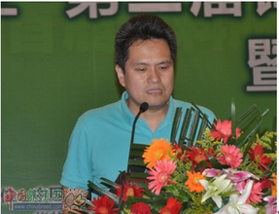 | 14:40-15:20 | Recent research development of gut microbiota and its application in aquaculture | Prof. Zhigang Zhou | Feed Research Institute of Chinese Academy of Agricultural Sciences
 | 15:20-15:30 | Coffee Break
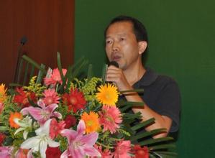 | 15:30-16:10 | Current status and trend of the management of Chinese feed formulator | Prof. Luliang Yang | Feed Research Institute of Chinese Academy of Agricultural Sciences
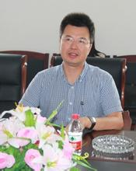 | 16:10-16:50 | Feed cost analysis of feed mills with different scales | Dr. Zelin Ren | Feed Research Institute of Chinese Academy of Agricultural Sciences
 | 16:50-17:20 | Question and discussion
 | 17:20-18:00 | Summary | Prof. Zhigang Zhou

